Lab 2 manual: Electric potential and equipotential lines
Dr. D. Beznosko
7/10/2026
For PHYS 2212L only
(Lab outcomes: advanced Excel skills, mapping of contour plot to experimental plot, electric field plot)

Abstract
This document describes the procedure to experimentally obtain the equipotential lines between the changes of different shapes, reproduce them in a spreadsheet software. In addition, electric field lines can also be drawn using the equipotential lines plots. Spreadsheet software is used to simulate the equipotential lines. Simulation is used to find the effective charge of the objects by fitting the scale and values of the potential. Electric field lines are drawn.

Introduction
Electric field lines are the imaginary lines. What do they tell us, why do we draw them? How do they relate to potential and why it is easier to use potential and equipotential lines to find the field itself? Why is the electric field always perpendicular to equipotential lines? Hint – can you explain this in your own words? Derivation will do as well but there will be no extra points for it.

Experimental Setup
The Overbeck apparatus is shown in Figure 1 and contains the apparatus itself, field plate, the power supply, galvanometer, voltmeter, probe, and a clear design template. The experiment also uses a regular letter sized paper page, pencil, and a ruler (not shown).

Procedure
Choose one of the field plates. Turn the field mapping board over and attach a field plate to bottom (conductive (silvery) side facing out) with plastic-headed thumb screws. Connect the potential source to the two binding posts on the upper side marked "Battery or Oscillator." Fasten a sheet of 8.5"x11" paper to the upper side of the board. Select a clear design template containing the field plate configuration that you have chosen, place it on the two metal projections, and trace the appropriate design. Remove the design template.
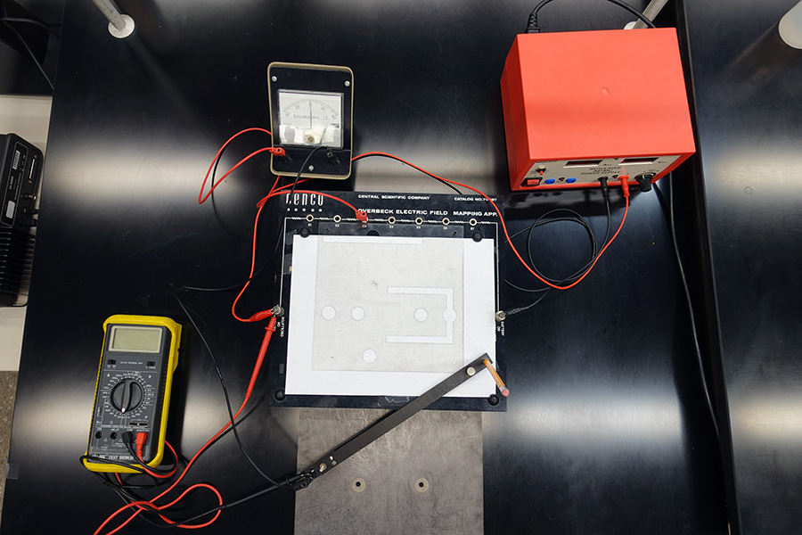
Galvanometer
Voltmeter
Power supply
Clear design template
Probe
Overbeck Apparatus
Paper and pencil
Field Plate
Potential ports
Figure 1: The experimental setup. Overbeck apparatus and other parts are shown and labeled. DON’T COPY ANYTHING FROM THE MANUAL!

Connect a wire to the first potential port and to the galvanometer. Connect another wire to the U-shaped probe and to the galvanometer. Carefully slide the U-shaped probe onto the mapping board with the ball end on the underside. Turn the potential source on to somewhere between 2 V and 4 V (ideal is around 3V).
Gently glide the probe over surface until the galvanometer reads 0. Mark this position on the paper through the center of the hole on the top of the probe using a pencil. Move the probe to another spot where meter reads 0. Mark this spot. Repeat until you have mapped out an equipotential line. Repeat this for all potential ports. Connect points of equal potential to form equipotential lines. These should not intersect anywhere!
Use the ruler to draw the horizontal line that connects the center points of the charged objects (for a plane, it should be a perpendicular line to planes surfaces). You can use the ruler also to estimate the center of the circular shapes.
Now choose an intersection of one equipotential line and this new line. Connect the probe back to the right potential port and move it around trying to find the 0 reading of galvanometer around this intersection. Mark each point. The spread (i.e. stdev) of x-distance to these points is your error in locating each point.
Measure the total voltage from the power supply and at the potential ports E1-E7. Think about the chosen voltmeter scale and the reading error! Measure one of those values at least 5 times, stdev of that is the statistical error you can use for all voltage measurements in this lab. On the same drawing, record the $(\frac{Total volage}{2}-current voltage)$ at each equipotential line. Some values should end up negative.
Draw in electric field lines. Repeat this procedure for all provided plates or as instructed.
What is the systematic error of the ruler? What about the voltmeter – does the manufacturer provide the precision that can be used as a systematic? It should be very small. Combine systematic and statistical errors into one as $\sqrt{statistical error² + systematic error²}$ .

Experimental Data
The results of the measurements should be organized similarly to Table 1. Think about how to organize this table. The error can be listed in a different column or as value ± error unit. Choose a center of one of the charges (a surface for a plane) as 0 and measure distances to all intersections. Use SI units! Also record the total distance between change centers, plane surfaces or a change center and a plane surface, or other – depending on the field plate used.
Table 1: Experimental data for which field plate?
Distance, m | Potential, V

Provide description about each entry as needed, don’t just leave the table without text in this section. Organize well so that data takes up less space, but everything needed is included.

Theory
Consider equation 1 that described the dependence of potential U on position x.
$$U=\frac{1}{4πϵ_{0}}\frac{q}{r} (1)$$
with $q$ being the point charge, and $r$ - the distance from that charge. Always use equation editor and number the equations so that they later can be referenced as eq. 1 or equation 1. Other equations may need to be used for this lab for other templates that you used. As potentials are scalars, they simply add together if there are multiple sources. It’s useful to remember that $r=\sqrt{{\left(x-x_{0}\right)}^{2}+{\left(y-y_{0}\right)}^{2}}$ .

Analysis
For analysis, we will do yet another new thing using Excel or similar spreadsheet software. Start with a provided excel template that matches the field plate that you have used in lab.
In the templates, adjust the kq1 and kq2 (or sigma1 and sigma2 as relevant), and the scale so that the distance between the charges/planes matches the measured value.
The voltmeter measured the potential difference, not the potential itself – it can’t be measured as a reference point is needed. How about your measurements – are they valid values for the potential? Where is the 0 for your measurements? How will you use the template to calculate the error on charge (sigma) from the errors on distance and voltage? Don’t actually calculate this error from equations, use the template at this step. Combine the errors arising from both sources into the single error in quadrature.
In your report, show the photos of your drawings and contour plots of the spreadsheets. What is the q1 and q2 or charge density? What is the possible error on these values? You can try to estimate this by adjusting the charges to march measured values with + or – their corresponding errors. From eq 1, express the change and find the $Δq$ for the measured voltages and distances that you have used in this analysis. Use the largest value and compare it with the value you measure from adjusting the charge method. Is the difference between them around 0.68? if so – why that specific value?

Conclusion
Remember to include references and appendices as needed. Comment on your result. What did you learn in performing this measurement? Where else can it be used? Can it be improved? Think about the comparison between the measured values and simulated – can some mathematical method be used to compare these or to look for the best charge values?

In your report, DON’T COPY this or any other section. I will consider copying any text from manual as error and lack of section even if you reference it, or even as plagiarism. Must be in your words, describing what you did in the lab. Might be different from this description as lab activities may not always follow the description provided exactly.
Another possibility is to measure shortest distances between all lines that you found and take the stdev of that measurement. This will also get a good estimate on the error of each point location.
Hint – can use the potential ports for the measurements, just remember which line corresponds to with port.

